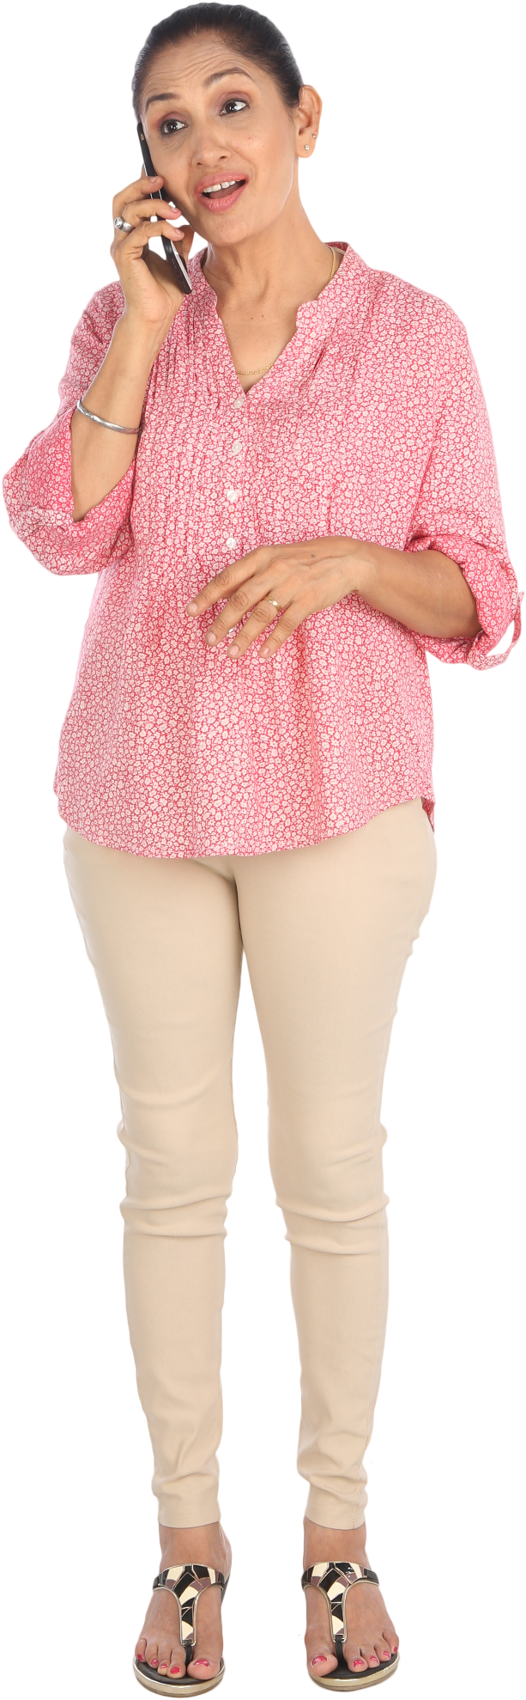

Susan C

**Job Title:**

* Stay at mom/ Blogger.
* Manages the household and takes care of the children.
* Manages a lifestyle blog

**Demographics:**

* Female
* 40
* Married
* Mother of 2 children
* Grandfather of one child
* Has a bachelor’s degree in Communication?

**Identifiers:**

* Extroverted and very outgoing.
* Very technology savvy.
* DIYer
* MBTI: ESFP



Jamie G

Background:

• Junior Accountant

Demographics

* Female 28
* Single, but goes on dates
* Workaholic
* Lives in the city in a loft
* Has a master’s in Finance.

Indentifiers:

* Very Introverted
* Does not like crowds prefers intimate settings.
* Has small group of friends.
* Frequent online shopper

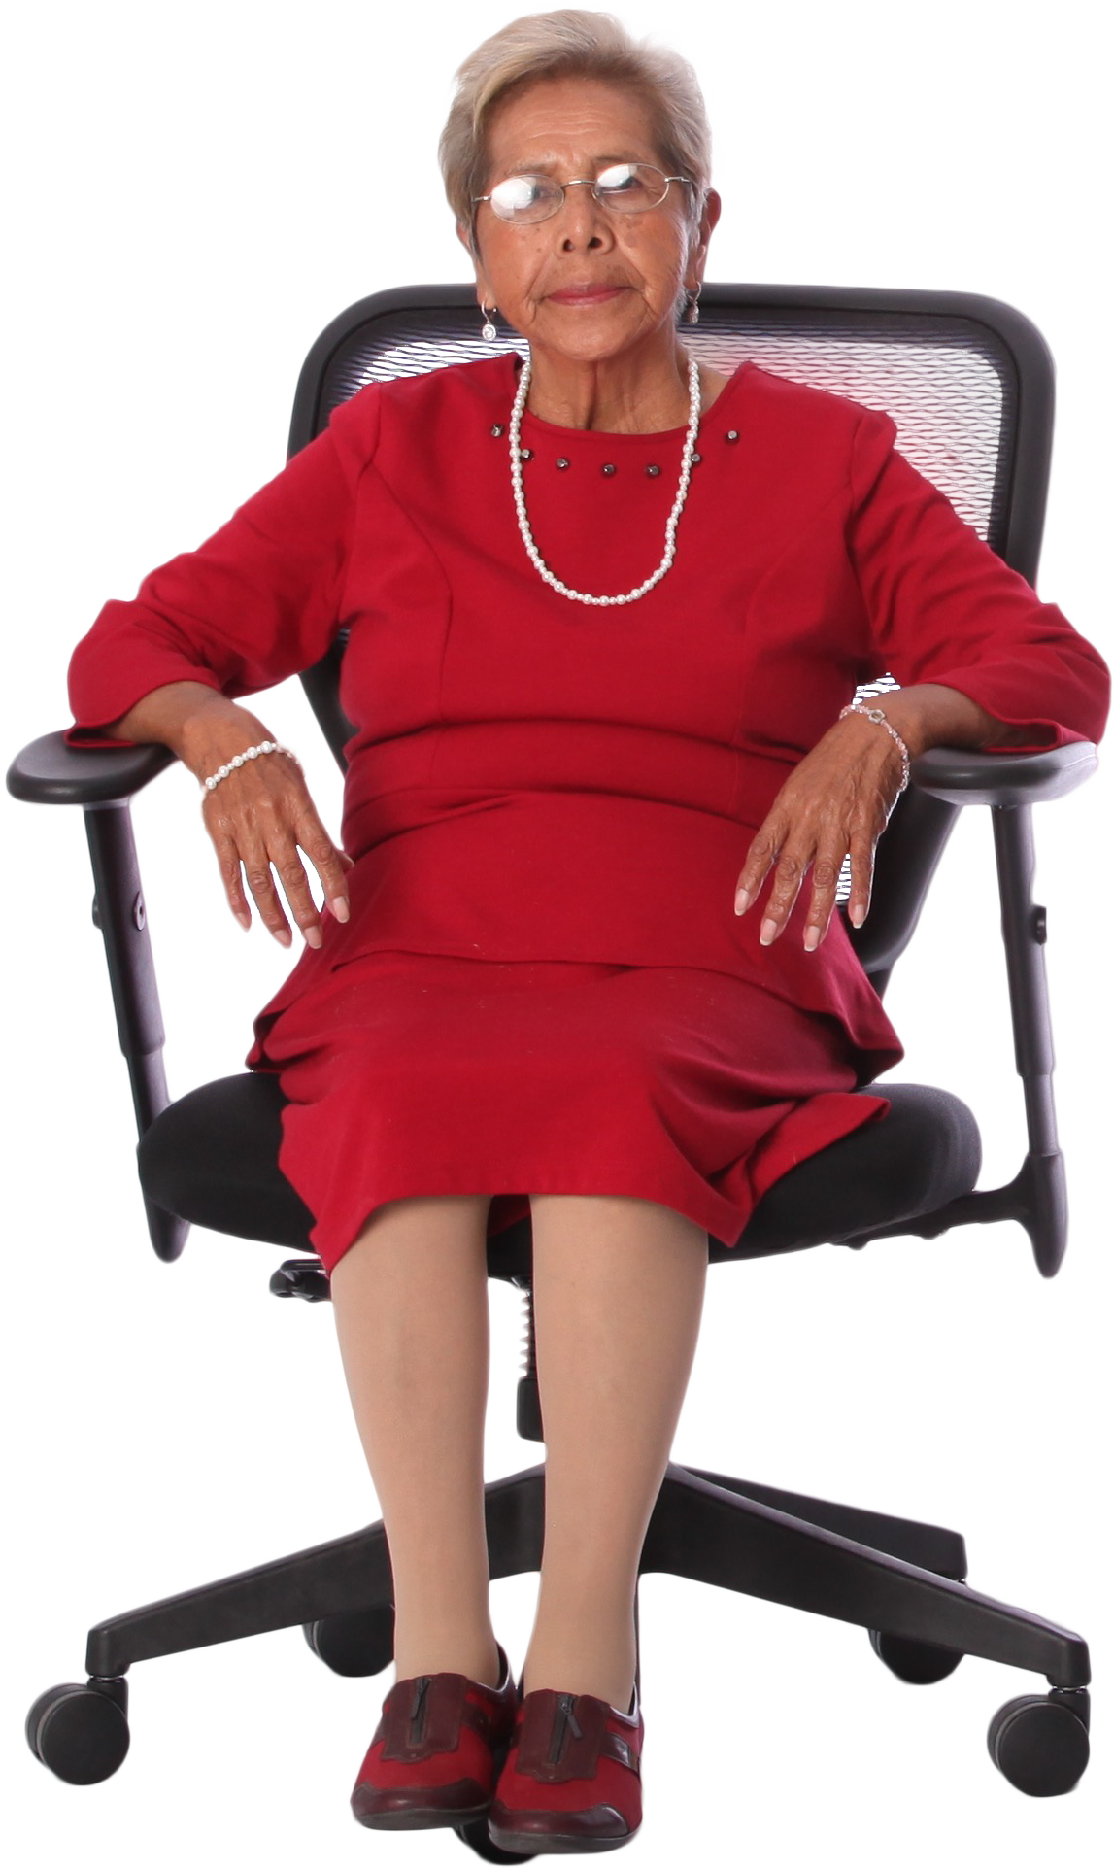

Mrs. Alice Rose

**Job Title**

* Retiree
* Spends Free time gardening, relaxing and spending time with grandchildren.

**Demographics:**

* Female, 65
* Income comes from Retirement.
* Part of a senior citizen community

**Identifiers:**

* Has an email address that was created by her grandchildren. She still needs a lot of help navigating websites.
* In between Extrovert and Introvert.
* Likes to stay on top of appearance.